A Mini Project Report on
Drowsiness & Attention Monitor using Transfer Learning

by

Ansh Rathod (22107022)

Gauri Iyer (22107030)

Sakshi Kadam (22107032)

Under the Guidance of
Prof. Ujwala Pagare



Department of CSE ( Data Science )
A.P. Shah Institute of Technology
G.B. Road, Kasarvadavli, Thane(W), Mumbai-400615 UNIVERSITY OF MUMBAI
Academic Year 2025 - 2026

CERTIFICATE

This is to certify that the mini project entitled “Drowsiness & Attention Monitor using Transfer Learning” has been successfully completed by Ansh Rathod (22107022), Gauri Iyer (22107030), and Sakshi Kadam (22107032).
The project is submitted in partial fulfillment of the requirements for the award of the Bachelor of Engineering in Computer Science and Engineering (Data Science) degree. The work presented in this report is the bonafide work of the above students carried out under the supervision of the project guide.

Subject In-charge
Prof. Ujwala Pagare

ACKNOWLEDGEMENT
We would like to express our sincere gratitude to our project guide Ms. Ujwala Pagare for her valuable guidance, encouragement, and continuous support throughout the completion of this mini project. Her suggestions and insights greatly helped us in successfully carrying out this work.

We are also thankful to Dr. Pravin Adivarekar, Head of the Department of Computer Science and Engineering (Data Science), for providing us with the opportunity and necessary facilities to undertake this project.

Table of Contents

Abstract |  |  | i
List of Figures |  |  | ii
List of Tables |  |  | iii
1. | Introduction |  | 1
 | 1.1 | Purpose/Overview of the project | 1
 | 1.2 | Problem Definition | 1
 | 1.3 | Objectives | 2
 | 1.4 | Dataset | 2
2. | Literature Review |  | 3
 | 2.1 | Related Work/Existing Systems | 3
3. | Methodology |  | 4
 | 3.1 | Proposed Methodology | 4
 | 3.2 | System Architecture/ Block Diagram | 5
 | 3.3 | Sample Code & Screenshots | 6
4 | Results and Discussion |  | 8
5 | Conclusion & Future Scope |  | 9
References |  |  | 10

Abstract

Maintaining student attention and mitigating fatigue are critical challenges in both modern educational environments and prolonged concentration tasks. This project presents a real-time Student Drowsiness and Attention Monitoring system designed to track user alertness using a lightweight, hybrid computer vision architecture. The proposed system captures live video feeds via OpenCV and employs Google MediaPipe’s FaceMesh to extract 468 precise 3D facial landmarks. To achieve high-accuracy drowsiness detection, the system utilizes a dual-verification mechanism: a geometric approach calculating the Eye Aspect Ratio (EAR) and a Deep Learning approach utilizing Transfer Learning.
Specifically, the geometric module dynamically monitors the vertical and horizontal distances between ocular landmarks, triggering an initial flag when the EAR falls below a calibrated threshold. Concurrently, a localized crop of the ocular region is processed by a custom-trained MobileNetV2 Convolutional Neural Network (CNN) to probabilistically classify the eye state as "Open" or "Closed." By fusing these two methodologies, the system achieves robust performance, mitigating false positives caused by varying lighting conditions or user accessories such as glasses.
The backend logic tracks consecutive frames of visual closure to dynamically calculate an Attention Score and log discrete "Drowsy Episodes." Upon detecting sustained fatigue, the system executes an asynchronous, low-latency audio alarm via Pygame to instantly alert the user. The entire pipeline is integrated into an interactive Streamlit dashboard, providing end-users with real-time biometric visualization, session analytics, and historical attention trends. Ultimately, this system provides a highly responsive, edge-deployable solution for non-intrusive cognitive state monitoring.

i

List of Figures

Fig no. | Figure name | Page no.
Fig 1.1 | Block Diagram | 5
Fig 1.2 | Live Monitor: Normal EAR and Awake State. | 7
Fig 1.3 | Drowsiness Alert Trigger and Visual Warning. | 7
Fig 1.4 | Post-Session Analytics Dashboard. | 7

ii

Chapter 1 Introduction

1.1 Purpose of the project:
The primary purpose of this project is to develop a non-intrusive, real-time monitoring system designed to detect fatigue and prevent lapses in student concentration. Utilizing standard webcam, the system aims to accurately assess cognitive alertness by combining geometric computer vision (Eye Aspect Ratio) with a deep learning classification model (MobileNetV2).

Ultimately, this project serves three main objectives:

Real-Time Intervention: To immediately alert a drowsy user through audio feedback before a critical loss of attention occurs.

Robust Accuracy: To minimize false positives caused by lighting changes or glasses by fusing mathematical landmark tracking with AI image classification.

Behavioral Analytics: To provide end-users and educators with a comprehensive dashboard containing session metrics and attention trends to help identify patterns in fatigue and improve long-term productivity.

1.2 Problem Definition:
In both educational environments and independent study scenarios, prolonged periods of screen time and continuous mental focus frequently lead to cognitive fatigue and drowsiness. This involuntary decline in alertness results in a significant reduction in comprehension, academic performance, and overall productivity.

While traditional physical classrooms allow for manual supervision by an instructor, this approach is unscalable, subjective, and prone to human error. In remote learning or self-study environments, manual monitoring is entirely absent. Furthermore, existing automated fatigue-detection systems often present significant barriers to entry: they either require expensive, specialized hardware (such as customized infrared sensors), or they rely on rudimentary, single-method software algorithms. These basic algorithms frequently generate false positives-such as mistaking a user looking down at their notes for a user falling asleep, or failing entirely when a user wears spectacles.

Therefore, there is a critical need for a highly accessible, non-intrusive monitoring system capable of operating efficiently on standard consumer hardware, such as a basic laptop webcam. The core problem requires a robust, real-time software solution that can accurately distinguish between natural blinking, momentary visual distraction, and genuine drowsiness, providing instant automated intervention to re-engage the user without requiring expensive equipment.

1
1.3 Objectives:
The core objective of this project is to build a responsive, non-intrusive monitoring system to detect student fatigue. Specifically, the project aims to:

- Implement Hybrid Detection: Combine geometric Eye Aspect Ratio (EAR) tracking with a MobileNetV2 deep learning model for highly accurate, real-time drowsiness detection.
- Deliver Instant Alerts: Integrate an asynchronous audio alarm that triggers during sustained eye closure and resets instantly the moment the user awakes.

- Track Cognitive State: Calculate a live "Attention Score" that dynamically measures user focus and automatically logs distinct drowsy episodes.

- Deploy a Live Dashboard: Develop a web-based Streamlit interface to visualize the real-time camera feed alongside live biometric metrics.

- Generate Session Analytics: Provide users with post-session performance statistics to help identify long-term fatigue patterns.

1.4 Datasets:
To train the Deep Learning image classification model (MobileNetV2), a specialized binary-class image dataset was utilized. The dataset strictly consists of cropped images of human ocular regions, categorized into two distinct classes: "Open Eyes" and "Closed Eyes".
To ensure the model is robust and performs accurately in real-world scenarios, the dataset encompasses a diverse range of conditions. This includes variations in ambient lighting, different head poses, varying ethnicities, and the presence or absence of spectacles. This diversity is crucial to prevent the model from overfitting and to ensure it can reliably classify eye states through a standard, low-resolution webcam feed.
Data Preprocessing Pipeline: Before feeding the dataset into the neural network for training, strict preprocessing transformations were applied to match the architectural requirements of MobileNetV2. As reflected in the system's live inference pipeline, the dataset undergoes the following automated steps:

- Dimensionality Standardization: Every image is strictly resized to a uniform dimension of 224 x 224 pixels.
- Color Space Conversion: Images are processed in the standard RGB (Red, Green, Blue) color space.
- Normalization: The pixel intensity values, which originally range from 0 to 255, are mathematically scaled (normalized) to a range of 0.0 to 1.0. This normalization stabilizes the training process and significantly improves the convergence speed of the neural network.

By structuring and preprocessing the dataset in this exact manner, the Transfer Learning model learns highly specific, localized features of the eye, allowing it to output a high-confidence probability score (model_open) during live video monitoring.

2

Chapter 2 Literature Review

2.1 Related Work/Existing Systems:
The detection of user fatigue and drowsiness has been a significant area of research, particularly in the fields of driver safety and online education. Historically, existing systems for drowsiness detection can be categorized into three primary methodologies:
1. Hardware and Physiological-Based Systems Early approaches to fatigue monitoring relied heavily on physical sensors attached to the user. These systems analyze physiological signals such as Electroencephalography (EEG) to monitor brain waves, or Electrocardiography (ECG) to monitor heart rate variability. Other hardware solutions involve active infrared (IR) cameras to illuminate the user's eyes in the dark.
- Limitations: While these physiological systems offer exceptionally high accuracy, they are highly intrusive, expensive, and completely impractical for everyday student use in a standard classroom or home study environment.
2. Traditional Computer Vision and Geometric Systems To overcome the intrusiveness of physical sensors, researchers shifted to software-based visual tracking. A seminal method in this category is the calculation of the Eye Aspect Ratio (EAR), which relies on mapping facial landmarks to calculate the distance between eyelids. Many existing systems use basic cascade classifiers (like Haar Cascades or Dlib) to locate the face and calculate this geometric ratio.
- Limitations: While computationally lightweight and fast, pure geometric systems are highly brittle. They frequently suffer from high false-positive rates when the user's face is partially obscured, when ambient lighting changes abruptly, or when the user wears spectacles that reflect light.
3. Deep Learning and CNN-Based Systems Recent advancements have applied Deep Learning, specifically Convolutional Neural Networks (CNNs) like VGG16 or ResNet, directly to raw webcam frames to classify the user's cognitive state. These models extract complex spatial features to determine if an eye is open or closed, making them highly resilient to lighting changes and glasses.
- Limitations: Traditional CNN architectures are computationally heavy. Running these large models continuously on standard consumer laptops often results in significant latency (frame drop), which delays the alarm trigger and disrupts the real-time monitoring experience.

3

Chapter 3

Methodology

3.1 Proposed Methodology:
The proposed system employs a lightweight, hybrid computer vision pipeline to monitor user fatigue in real-time. The operational methodology is divided into five sequential phases:
Phase 1: Real-Time Data Acquisition The system captures a continuous video stream via a standard webcam using the OpenCV library, immediately converting each frame into the RGB color space for processing.
Phase 2: Geometric Tracking (EAR Calculation) Frames are processed by Google MediaPipe FaceMesh, which maps 468 precise 3D facial landmarks. The system extracts the eye coordinates to calculate the Eye Aspect Ratio (EAR)—the ratio of vertical to horizontal eye distances. If the EAR falls below a calibrated threshold (e.g., 0.28), it flags a potential eye closure.
Phase 3: Deep Learning Classification (MobileNetV2) Simultaneously, OpenCV crops a bounding box specifically around the user's eye. This crop is resized to 224x224 pixels, normalized, and evaluated by a custom-trained MobileNetV2 model (Transfer Learning) to probabilistically classify the eye as "Open" or "Closed".
Phase 4: Hybrid Fusion and Intervention The system evaluates the cognitive state using a logical OR condition: a frame is classified as "closed" if either the geometric EAR falls below the threshold or the Deep Learning model predicts an open probability of less than 50%. If this state persists for 10 consecutive frames, an asynchronous Pygame audio alarm triggers to alert the user. The exact millisecond the user's eyes reopen, the alarm forcefully terminates.
Phase 5: Dynamic Scoring and UI Rendering Throughout the session, the system calculates a dynamic "Attention Score," which degrades by 0.4% during closed-eye frames and recovers by 0.15% during open-eye frames. These live biometrics, alongside the camera feed and session analytics, are seamlessly rendered onto an interactive Streamlit web dashboard.

4

3.2 System Architecture/ Block Diagram:
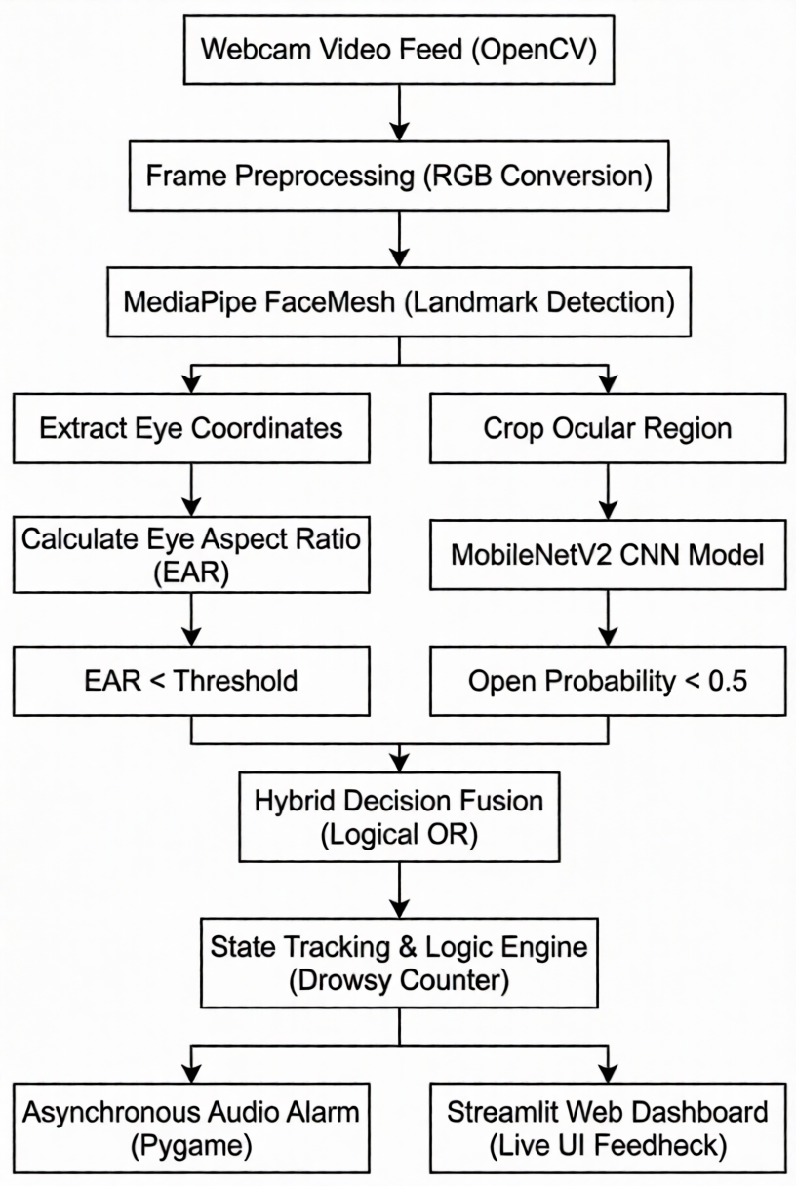
Fig 1.1 Block Diagram

5
3.3 Sample Code & Screenshots:
A. Geometric Detection (EAR Calculation):
This snippet demonstrates how facial landmarks are extracted using MediaPipe to calculate the Eye Aspect Ratio.
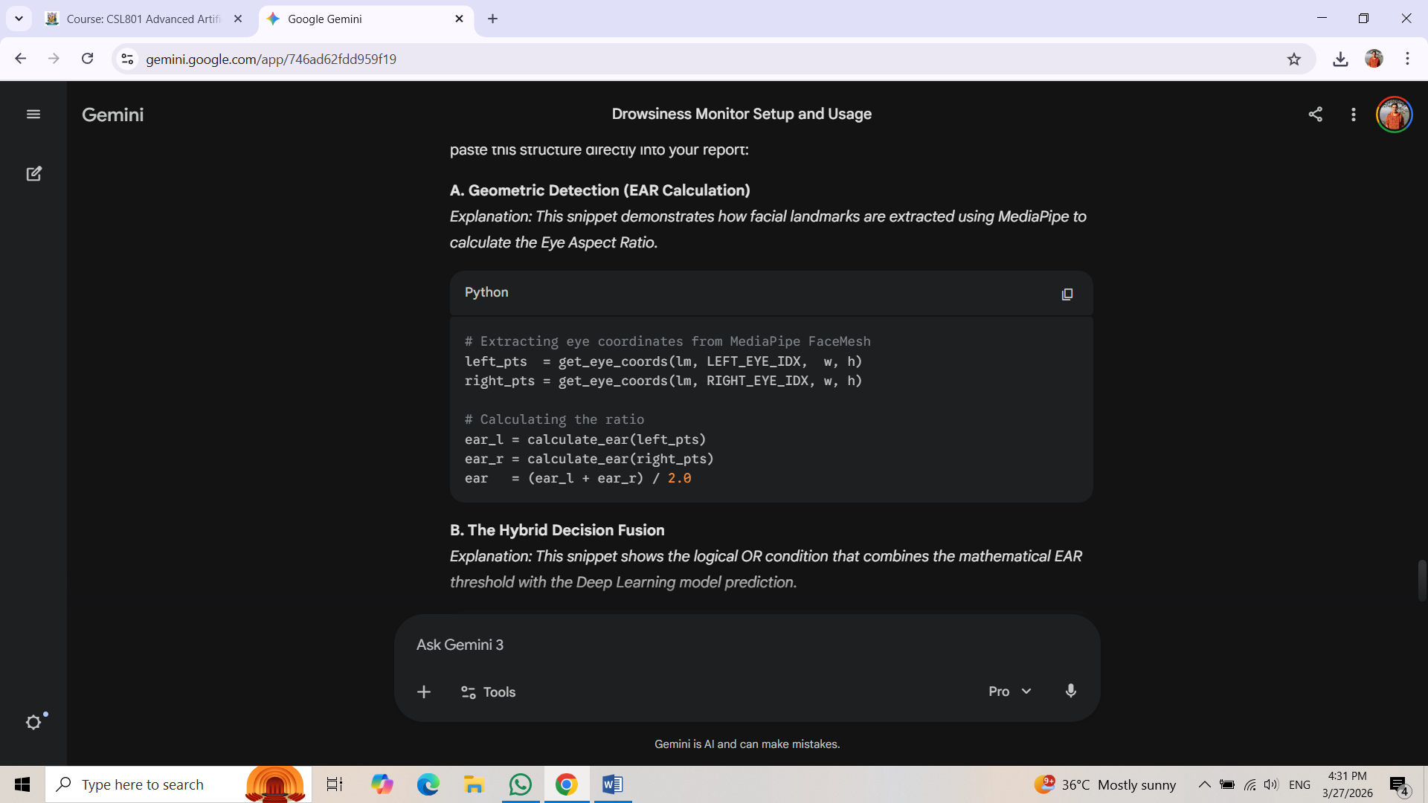

B. The Hybrid Decision Fusion:
This snippet shows the logical OR condition that combines the mathematical EAR threshold with the Deep Learning model prediction.
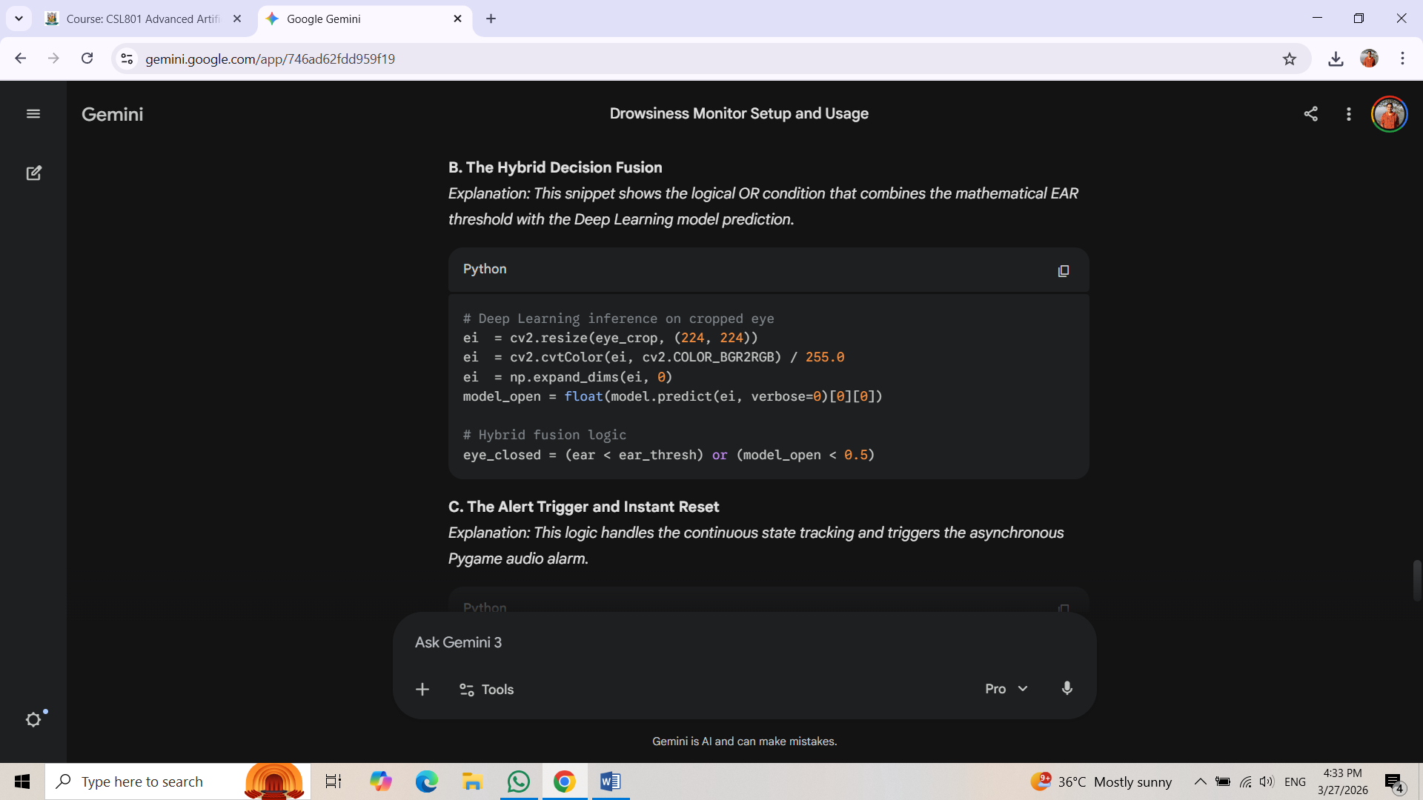

C. The Alert Trigger & Instant Reset:
This logic handles the continuous state tracking and triggers the asynchronous Pygame audio alarm.
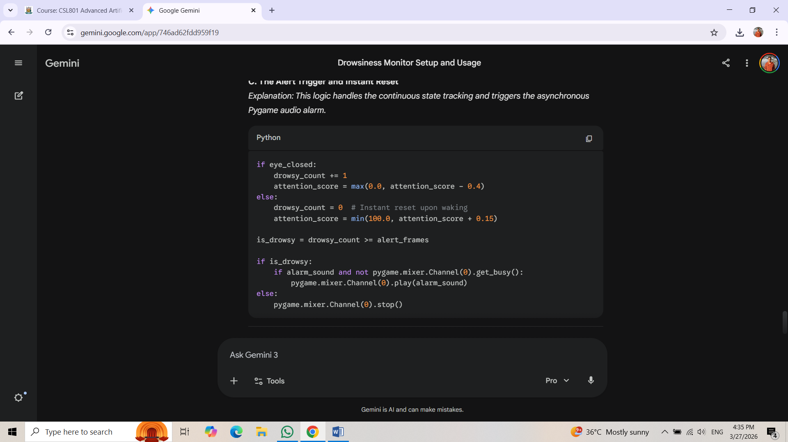

6
- Screenshots:
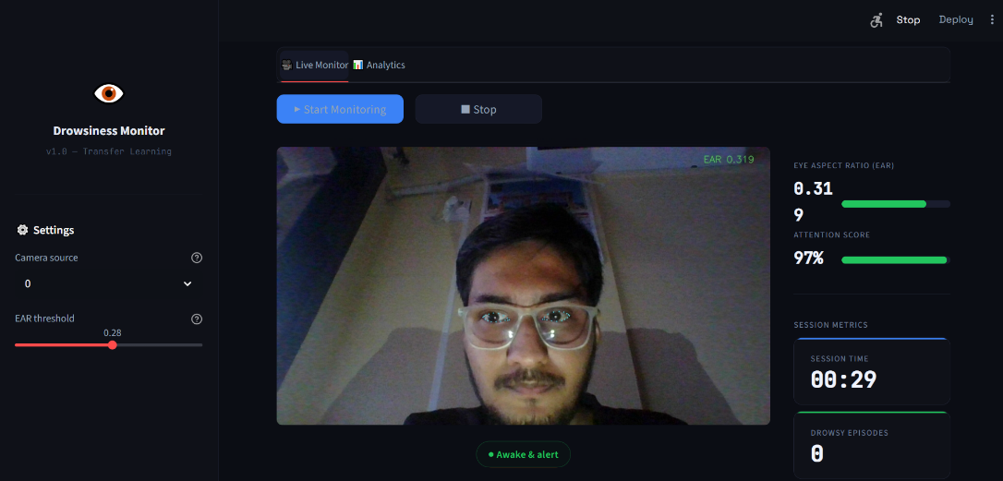
Figure 1.2 Live Monitor: Normal EAR and Awake State.

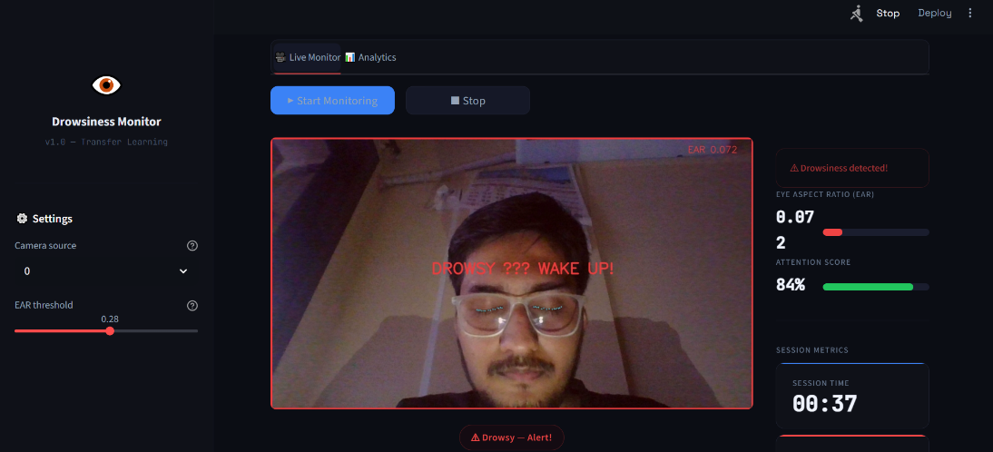
Figure 1.3 Drowsiness Alert Trigger and Visual Warning.

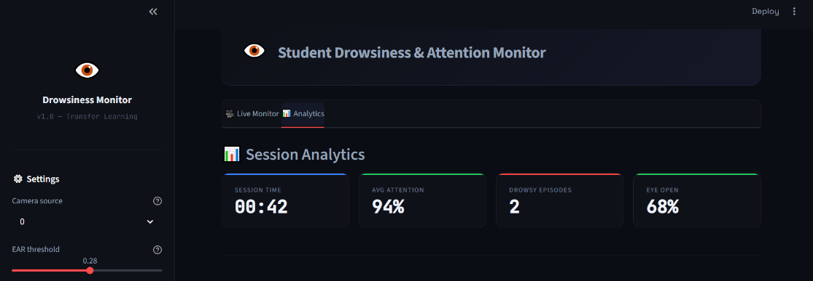
Figure 1.4 Post-Session Analytics Dashboard.

7

Chapter 4 Results and Discussion
The deployment and testing of the Student Drowsiness and Attention Monitor yielded highly successful outcomes, demonstrating that a lightweight, hybrid computer vision architecture can effectively operate on edge devices. Testing was conducted using a standard consumer webcam under typical indoor lighting conditions. The system successfully executed real-time frame processing, biometric extraction, and asynchronous alerting without causing UI latency or camera freezing within the Streamlit environment.
A critical finding from the system's evaluation is the superiority of the Hybrid Decision Fusion approach over traditional single-method systems. Historically, relying purely on the geometric Eye Aspect Ratio (EAR) results in a high rate of false positives; instances where a user looks down at a keyboard or wears highly reflective spectacles often trick the EAR math into registering a "closed" eye. By integrating a MobileNetV2 Convolutional Neural Network as a secondary spatial verification layer, the system's robustness increased significantly. The logical evaluation—flagging a frame as drowsy only if the EAR falls below 0.28 or the deep learning model calculates an open probability of less than 50%—effectively eliminated standard environmental false positives.
In terms of real-time intervention, the system's logic engine proved highly reliable. The strict 10-frame consecutive closure threshold successfully differentiated between natural, slow blinking and genuine cognitive fatigue. Furthermore, the integration of asynchronous audio threading via Pygame allowed the warning alarm to trigger instantly without interrupting the video feed. A notable success in the system's logic is the instant-reset mechanism; the exact millisecond the hybrid model detects ocular reopening, the alarm terminates, preventing user frustration and ensuring the system is strictly non-intrusive.
Beyond real-time alerting, the project successfully expanded from a simple binary alarm into a behavioral analytics tool. The formulation of the dynamic "Attention Score"—which mathematically degrades during closed-frame events and gradually recovers during active focus—provided a highly accurate quantitative metric of user alertness. When aggregated into the post-session Analytics dashboard, these metrics provide educators and students with actionable insights into fatigue patterns.
However, a recognized limitation of this architecture is its dependence on standard optical input. Because MediaPipe FaceMesh relies on visual clarity to map 3D landmarks, extreme low-light environments or severe backlighting can degrade detection accuracy. Future iterations of this project could address this limitation by applying automated low-light image enhancement preprocessing techniques to the webcam feed prior to feature extraction. Overall, the system achieves its primary objectives, delivering a highly responsive, accurate, and analytical approach to student fatigue monitoring.

8

Chapter 5

Conclusion & Future Scope

The Student Drowsiness and Attention Monitor successfully achieves its primary objective of providing a robust, real-time, and non-intrusive solution for detecting cognitive fatigue. By engineering a hybrid computer vision architecture that fuses the mathematical precision of the Eye Aspect Ratio (EAR) with the spatial pattern recognition of a MobileNetV2 deep learning model, the system effectively overcomes the high false-positive rates that typically plague traditional single-method detectors. The implementation proved that advanced biometric tracking can be efficiently deployed on standard consumer hardware without latency, utilizing asynchronous Pygame audio threading to deliver instant intervention exactly when the 10-frame fatigue threshold is breached, while instantly resetting when alertness is regained. Furthermore, by rendering dynamic cognitive metrics - such as the Attention Score - onto an interactive Streamlit web dashboard, the project successfully transcends a simple reactive alarm, functioning instead as a comprehensive behavioral analytics tool.
While the current implementation is highly effective, the modular nature of the Python backend allows for several significant future enhancements. First, the system's tracking capabilities could be expanded beyond ocular closure by utilizing the existing MediaPipe FaceMesh landmarks to calculate head pose (yaw, pitch, and roll). This would allow the system to detect when a student is completely awake but visually distracted (e.g., looking down at a phone). Second, to mitigate the optical limitations of standard webcams in dark study environments, an automated preprocessing layer utilizing low-light image enhancement algorithms (such as CLAHE) could be introduced. Third, integrating a cloud-based database (such as Firebase or MongoDB) would allow users to permanently save their session analytics, generating long-term reports on their study habits over an entire semester. Finally, the core logic could be repackaged as a lightweight browser extension or WebAssembly (Wasm) module, allowing the drowsiness monitor to run seamlessly in the background of existing remote-learning applications like Zoom, Google Meet, or online examination platforms.

9

Chapter 6

References

[1] Soukupová, T., & Čech, J. (2016). Real-time eye blink detection using facial landmarks. 21st Computer Vision Winter Workshop (CVWW), 1-8.

[2] Sandler, M., Howard, A., Zhu, M., Zhmoginov, A., & Chen, L. C. (2018). MobileNetV2: Inverted residuals and linear bottlenecks. Proceedings of the IEEE Conference on Computer Vision and Pattern Recognition (CVPR), 4510-4520.

[3] Kartynnik, Y., Ablavatski, A., Grishchenko, I., & Grundmann, M. (2019). Real-time facial surface geometry from monocular video on mobile GPUs. arXiv preprint arXiv:1907.06724.

10

